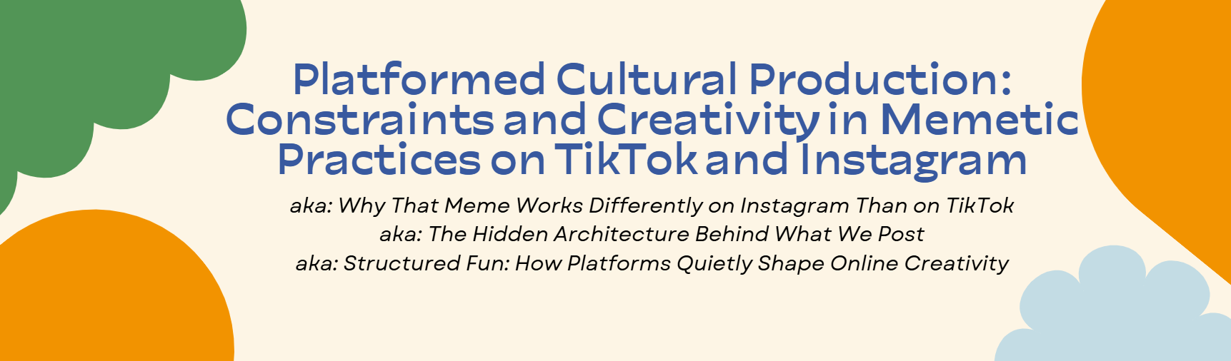

### **Why This Version Exists**

This is a version of my dissertation written for the people I care about — the ones who’ve asked me, patiently, what my research is about, who’ve listened to half-explained tangents about TikTok or Instagram or platform affordances, and who maybe aren’t in the habit of reading academic work for fun.

It’s not simplified. It’s clarified. The big ideas are still here — about creativity, structure, culture, and power — but they’re delivered in a way that respects your time and invites you in.

This project uses memes to explore how social media platforms really work — not just what features they offer, but how they shape what people make, how they’re seen, and who gets to be heard. It’s about TikTok and Instagram, yes — but also about the systems quietly shaping online culture.

The cartoon on this page captures something familiar: even when you’re trying to be clear, it’s easy to forget what other people *don’t already know*. This document is my attempt to remember that — and to offer an explanation that makes sense, even if you’ve never used the word “meme” in a sentence with “cultural production.” This is the version I hope you’ll actually enjoy reading.

## 

## **Acknowledgements**

This project took years — not just to research and write, but to carry alongside life. It never felt like the center of my world, and I think that’s why I’m proud of it. It lived around the edges — at night, on weekends, during June’s naps — and I owe so much to the people who made space for that to happen.

First and always, to Devon — my wife, my partner, my clarity check. There’s no version of this project, or this life, without you. You’ve read more drafts than anyone should ever have to. If it didn’t make sense to you, it didn’t make sense at all — and I trusted that completely. You carried the emotional weight, the family weight, the invisible weight of me working strange hours, being stuck or stressed or sometimes insufferable. Thank you for all of it.

To our daughter, June — you’ve had no idea what I’ve been doing on the computer all this time, and I love that for you. Becoming your dad is the best thing I’ve ever done. This PhD was worth it for many reasons, but if nothing else, it gave me the chance to be home with you during your first years. You reminded me what actually matters, and clarified what I want — not just in a job, but in a life.

To my mom — your support made this possible in every sense. You came to New Orleans again and again so I could write, and your steady presence gave me space to work and breathe. You’ve always led with love and generosity, always quick to ask what you can do for others. I’ve come to see more of myself in you over the years — our quirks, our tidiness obsession, our gift for noticing what people need. You’ve been a loving grandparent to June and a constant encouragement to me. I’m so grateful — and I see now how much you’ve shaped the way I show up in the world.

To Kate — my sister, sounding board, and professional question-asker. You listened to more dissertation rambles than anyone else — Python, TikTok, whatever strange research method I was chasing that week — and always stayed curious without letting me get away with nonsense. I’m lucky to have you in my life.

To my dad — thank you for laying the foundation. You celebrated every win, noticed every effort, and showed me that hard work and curiosity mattered. That belief has stayed with me.

To Travon — thank you for letting me talk about TikTok more than anyone should have to endure, even if you never answered a single question. Watching you grow over these past few years has been one of the greatest joys of my life. I’ve never admired you more.

To my wider family — Sharon and Guy, Brian and Stephanie, Derek and Steph, Mimi, Chol and Diann, FD and Robbie — thank you for listening to my ramblings, asking good questions, and letting me bring this weird world into your lives.

To my Nana, who passed away in 2021 — you were the most joyful, generous person I’ve ever known. You were never in a rush. Whoever was in front of you got your full focus. You saw me begin this journey, and I know you would’ve been proud to see it end.

To my sponsor, WH, and the people of Alcoholics Anonymous — getting sober during this process didn’t just change my life; it gave me a new one. There is no place I’ve ever felt more at home than in a room full of people whose brains are broken in the same way as mine. The honesty, the laughter, the lightness — it saved me. To keep the gift, you have to give it away. I hope I can keep doing that.

To St. Roch Community Church — you’ve been the heart of my New Orleans life. You held me through adulthood, supported me after June’s birth, and gave me a place to be fully myself. I’ll be looking for a church like you for the rest of my life.

This dissertation may be “mine,” but it was built on the time, trust, and care of many others. I hope this version helps show what your support helped make possible.

## **Chapter 1: Rethinking Memes — and the Platforms Behind Them**

What do you think of when you hear the word *meme*?

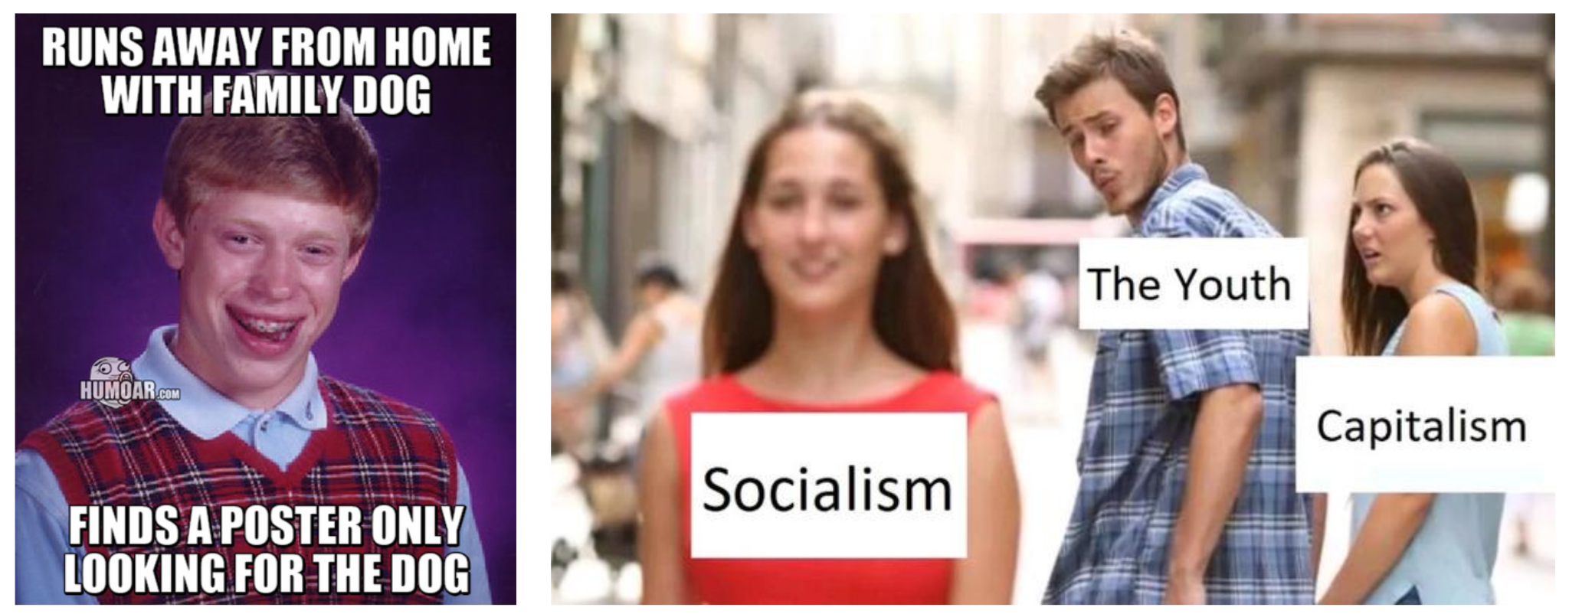

Maybe it’s something like *Bad Luck Brian* or *Distracted Boyfriend* — a still image with bold white text, shared on Facebook or Reddit. Or maybe it’s something more recent: a TikTok sound that everyone’s using, or a phrase like “girl dinner” that somehow becomes both joke and lifestyle. Over time, memes have changed — from single images to looping videos, from static jokes to recognizable sounds, trends, or formats.

So what actually counts as a meme today?

If the formats have evolved, maybe our definitions should too.

In the early days of the internet, memes were usually funny pictures — something you *looked at*, not something you *did*. But now, memes are just as much about *participation* as they are about content. That might mean copying a trend, remixing a sound, imitating a skit, tweaking a caption, or layering your own twist onto something familiar.

| **KEY TERMS** |
| --- |
| **Meme:** A unit of culture that spreads by being copied and adapted — like a joke, image, video, or phrase that people recognize and remix. |
| **Memetic Practice:** The creative and strategic things people do to make and share memes — like editing a sound, reworking a caption, or mimicking a trend. |
| **Structured Participation:** The idea that online creativity isn’t freeform — it’s shaped by the platform’s design, values, and algorithmic logic. |

Early internet culture largely treated memes as humorous visuals — something you *see*. But now, memes are also things you *do*: imitating a skit, remixing a sound, riffing on a recognizable format, or adding your own twist to a trend. Memes aren’t just content — they’re actions. And that shift matters.

Scholars have been studying memes for decades. In 1976, biologist Richard Dawkins introduced the word *meme* in his book *The Selfish Gene*. He used it to describe how certain ideas — like tunes, slogans, or sayings — spread from person to person, the way genes spread in biology. Later, psychologist Susan Blackmore expanded on this idea, suggesting that memes “evolve” as they spread: they compete for attention, change slightly with each version, and rise or fall based on how easily they catch on.

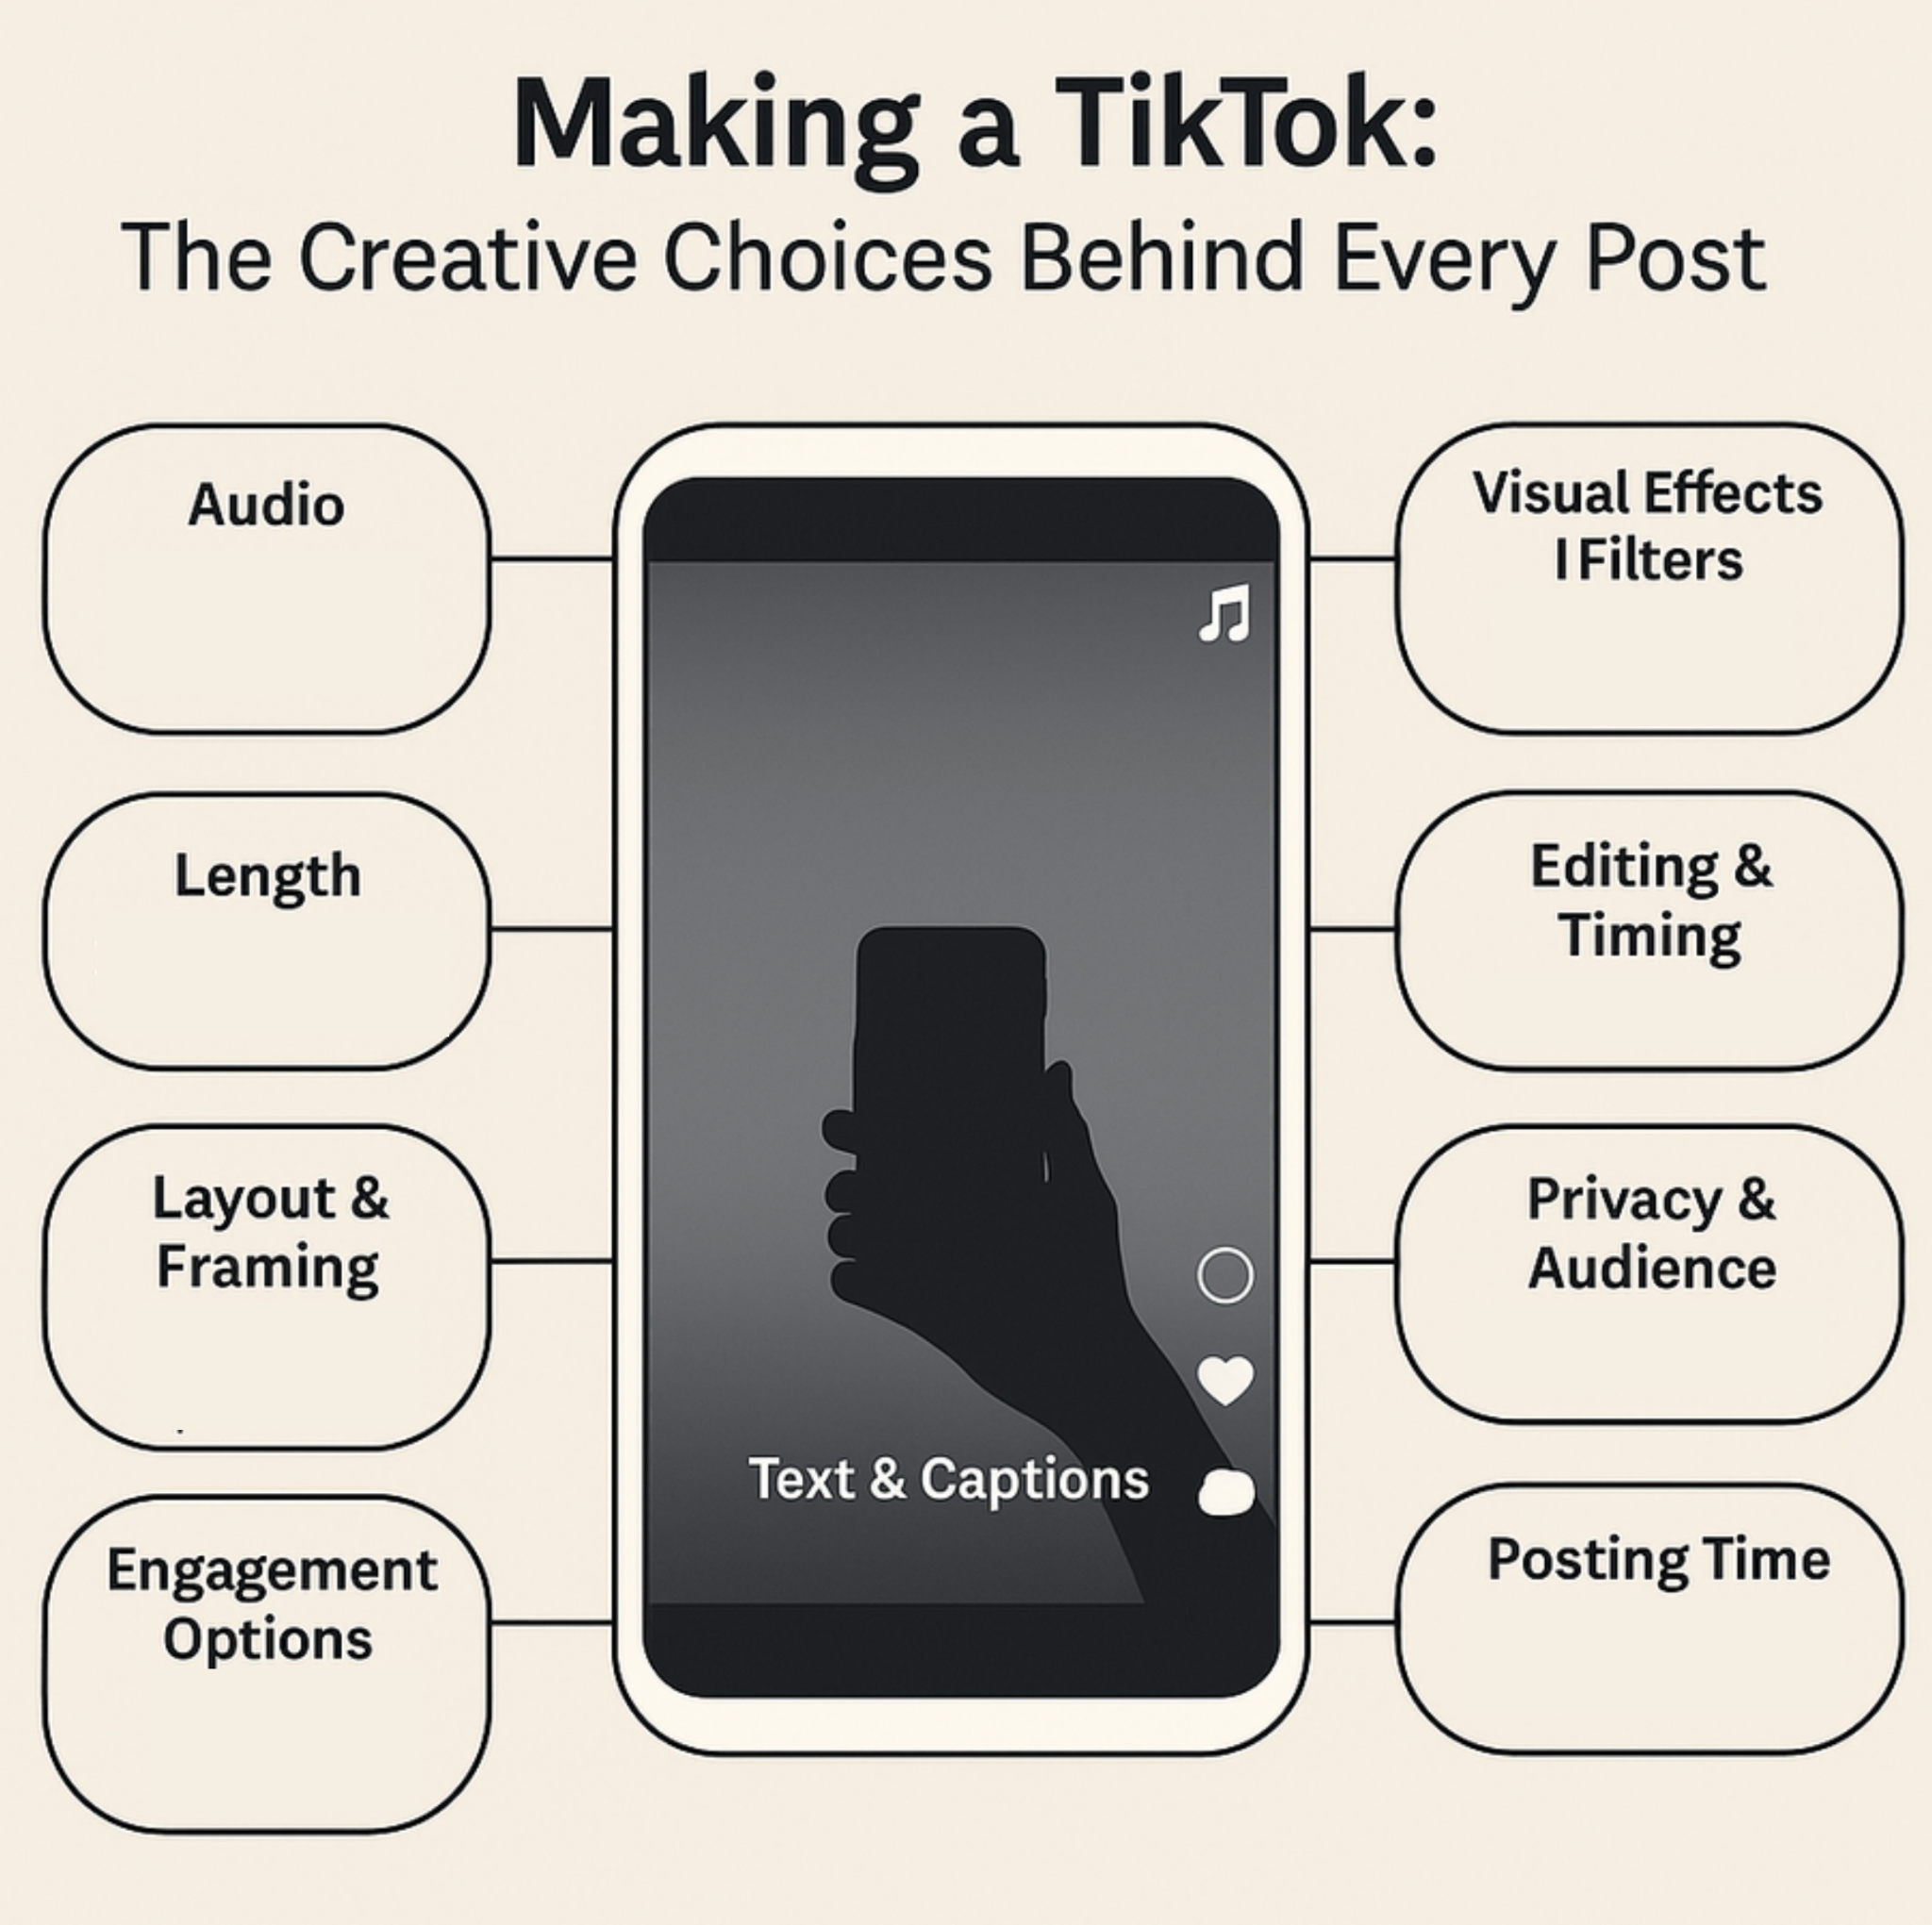

But those early theories focused mostly on *how* memes spread — not what they *mean*, or what people actually *do* to bring them to life.

More recent researchers — like Limor Shifman, Whitney Phillips, and Ryan Milner — shift the focus. Instead of seeing memes as little units of replication, they see them as **cultural tools**: ways people express themselves, connect with others, make jokes, navigate identity, or respond to current events. These scholars helped reframe memes as something people *use* — socially, politically, creatively.

My work builds on that shift, but pivots once more — to **practice**. I focus less on what a meme *is* and more on what people *do* with them. I call these **memetic practices**: the creative, often collaborative steps people take to make a meme — choosing a sound, editing a clip, parodying a trend, posting at the right time, tailoring it for the audience they hope will see it.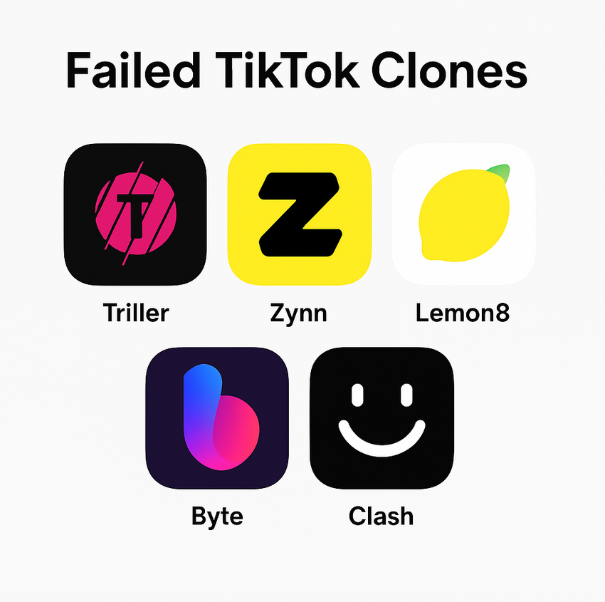

And once we start tracing those practices, we start to learn something even bigger — not just about people, but about the platforms themselves.

Take TikTok. In 2023 and 2024, the U.S. government moved toward banning the app over data privacy concerns. During that time, a bunch of alternatives launched — apps like Lemon8, Triller, and Zynn — but none of them caught on. You probably haven’t used them. Most people didn’t.

If TikTok were just a scrollable video feed with editing tools, it should’ve been easy to copy. But it wasn’t. Why?

Most people talk about TikTok and Instagram as **apps** or **social media** — and that’s not wrong. But in this project, I use the word **platform** on purpose. A platform isn’t just a piece of software — it’s a system. It includes tools, rules, algorithms, design features, content policies, and business models that shape how culture gets made and seen.

But the word *platform* does more than describe a technical system — it also carries a kind of built-in metaphor. As media scholar Tarleton Gillespie points out, calling something a platform **makes it sound neutral and open — like a stage anyone can use.** But in reality, platforms set rules, make choices, and shape outcomes. They don’t just host content — they structure it.

That’s why this project uses memes to study platforms: memes aren’t just fun or fleeting. They make the platform’s underlying logic visible.

TikTok isn’t just a set of features. It’s a whole **system** — of norms, values, rhythms, remix tools, and recommendation algorithms — that shape how people create and connect. That’s what makes TikTok TikTok. And that’s not easy to replicate.

This dissertation uses memes — and the practices around them — to better understand platforms. It argues that TikTok and Instagram aren’t just apps. They’re environments that influence how people express themselves. I call this **structured participation**: the idea that what people make online is shaped by the platforms they use — what’s encouraged, what’s rewarded, what’s possible, and what’s invisible.

Even the life of a meme — how it spreads, how it shifts, how it dies out — is shaped by these hidden structures.

So instead of asking, what is a meme, this project asks a different question:

***What can memes reveal about the platforms we use every day?***

## **Chapter 2: What Platforms Say They’re About — And What That Tells Us**

You’ve probably heard some version of it before: *TikTok is rotting kids’ brains.* *Instagram is fake.* *Facebook is for Boomers.* Worries about social media are everywhere — from casual complaints to bestselling books like Jonathan Haidt’s *The Anxious Generation*. People talk about spending too much time on their phones, losing focus, or feeling pressured to perform for likes and views.

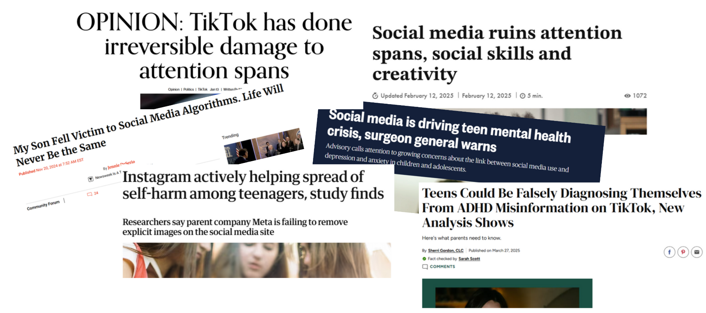This project isn’t another social media panic. It doesn’t ask whether these platforms are good or bad. Instead, it zooms in — to understand how they actually work, and how they shape culture in the process.

It starts with a simple but important idea: platforms don’t just give people tools.

They also promote values.

And they communicate those values constantly — not just through marketing or public statements, but through the design of the app itself. What shows up first. What’s easy to do. What’s rewarded or quietly discouraged. From algorithmic suggestions to onboarding screens, help center advice to design defaults, platforms are always sending signals about how they think content should work.

If you start paying attention, you’ll notice that TikTok and Instagram use many of the same words to describe themselves — words like **authenticity**, **creativity**, **community**, and **discovery**. These values appear everywhere: in ads, in interface text, in safety policies and press releases.

At first glance, these values feel almost too familiar — who wouldn’t want authenticity or community? But if you look closer, you’ll see that each platform means something different by those same words.

Take **authenticity**. On TikTok, it often means something raw and spontaneous — a shaky selfie video, an inside joke, a clip of someone laughing at themselves. The app’s design encourages that kind of quick, unfiltered sharing. On Instagram, “authenticity” might look more curated — like a perfectly imperfect “photo dump,” where the messiness feels intentional but still aesthetic. Both apps promote the same word, but they reward very different behaviors.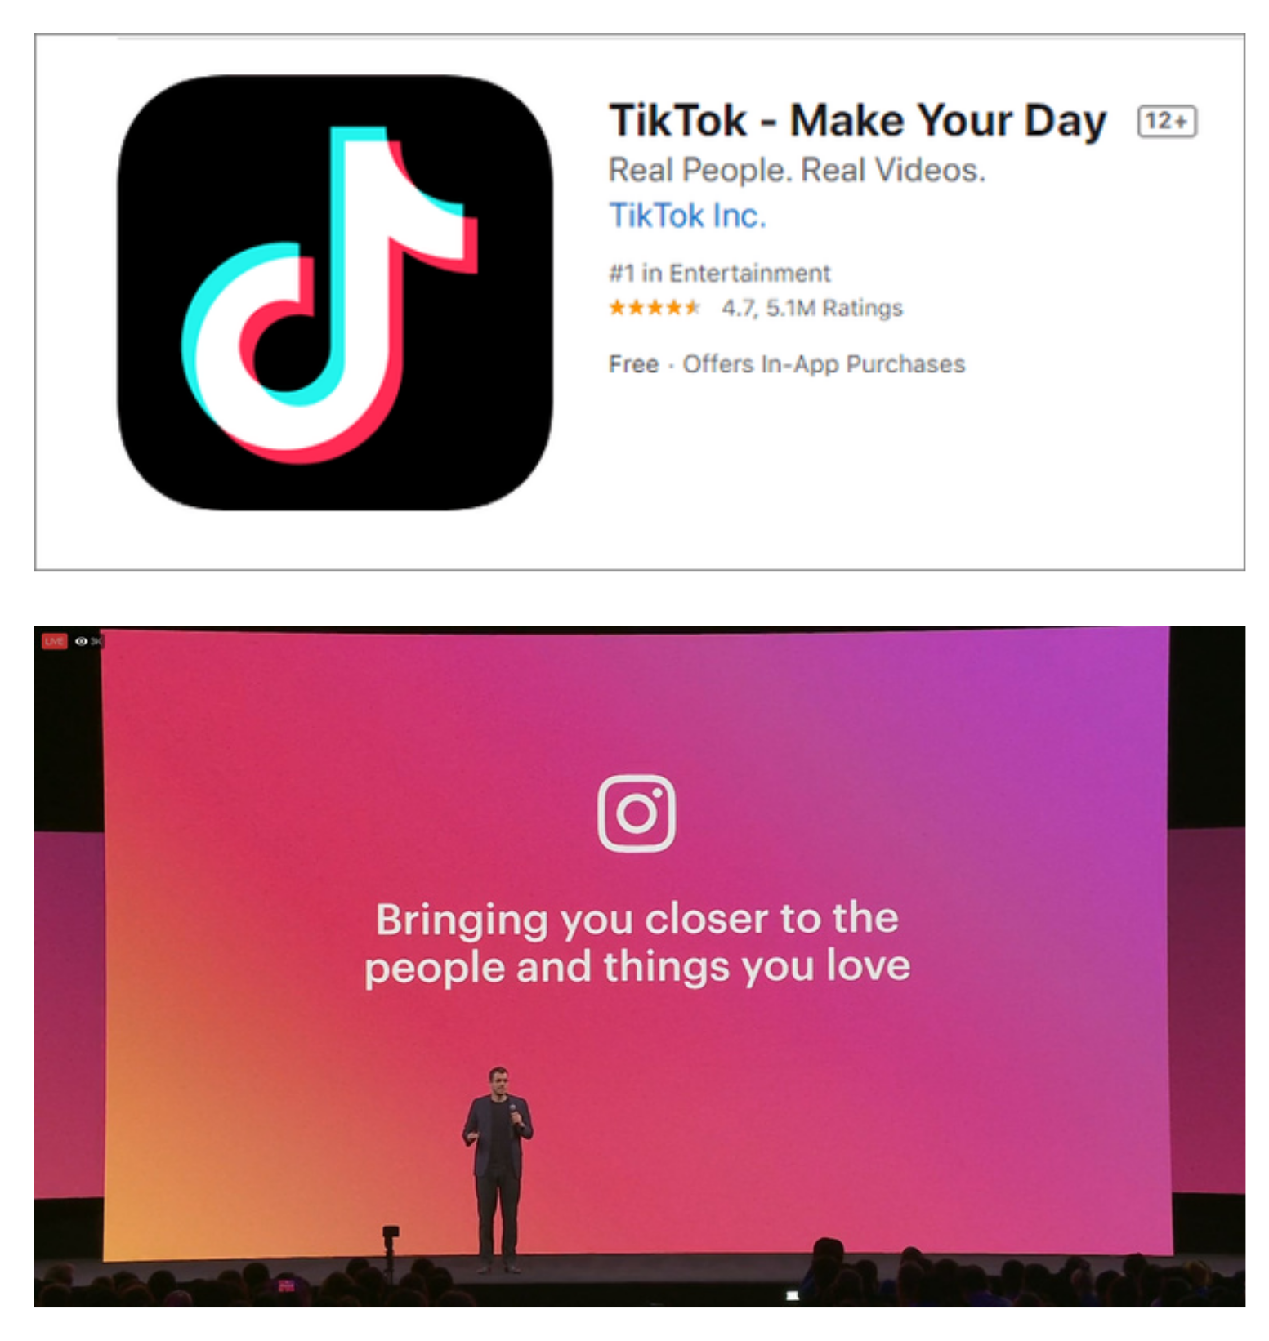

Or take **discovery**. TikTok shows you videos from people you’ve never met, sometimes from across the world. It builds a sense of randomness and surprise, like anything could show up on your feed. Instagram, by contrast, mostly shows you content connected to people you already follow, or accounts that resemble your past interests.

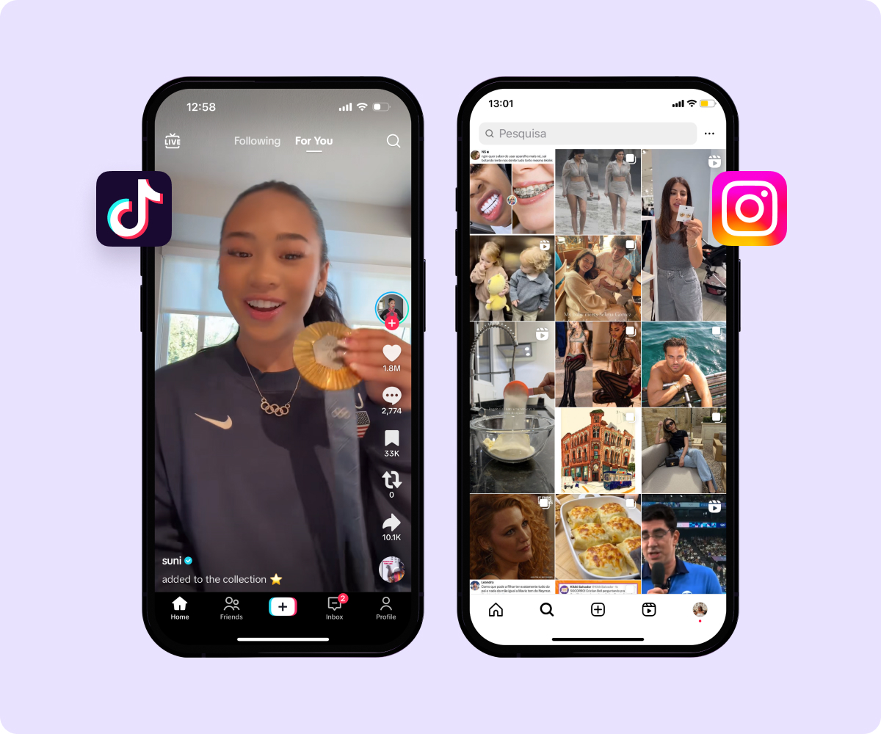

These differences may seem small — but they quietly shape what people post, who they imagine their audience to be, and how they choose to present themselves. They also help explain why memes often behave differently on TikTok versus Instagram, even when they look similar on the surface.

So while both platforms say they care about the same values, they build those values into their systems in very different ways. They don’t just promote creativity or community — they design their own versions of what those things should look like.

What you’re really seeing is this: the platform’s values, translated into its structure — the look of the interface, the pace of the feed, the kinds of content that rise to the top. Later, I’ll call these differences **platform vernaculars**. They’re not just style choices. They’re blueprints for how culture is built.

Understanding these value systems — and the design choices behind them — is a key step toward understanding what happens when people try to navigate, adapt to, or push back against the pressures of life online.

## **Chapter 3: What It Feels Like to Post — And How People Make It Work**

Ever spent 10 minutes wondering if your post was too cringe? Worried that copying a trend would make you look unoriginal — but also knew that *not* copying it might mean no one would see it at all?

That feeling isn’t just about anxiety or self-consciousness. It’s not just in your head — it’s baked into how social media works

Social media sharpens tensions people already feel: the push to be authentic, but also perform; to stand out, but still fit in; to be creative, but also recognizable. These aren’t just internal dilemmas — they’re shaped by the way platforms are designed and how they reward content.

To navigate these competing impulses, people develop strategies. They don’t just post. They *calibrate*. They remix trends in ways that feel personal. They adopt styles that feel natural on that platform while trying to retain some sense of individuality. They participate in shared formats — memes, templates, captions — but twist them just enough to feel new.

I call this process **memetic negotiation** — the ongoing, often subtle way that people manage social and platform tensions through the practice of meme-making.

It’s a bit like learning the unspoken rules of a new workplace or classroom — you pick up on what kinds of behavior are encouraged, which ones get rewarded, and how to play along while still being yourself.

Across TikTok and Instagram, I found three key tensions that users repeatedly negotiate — and a set of adaptive strategies that emerge in response:

### **1. Authenticity vs. Performance → Calibrated Authenticity**

People want to be real — but also want to be seen, liked, and understood. On TikTok, users often strike this balance through casual storytelling or self-aware humor. A “Get Ready With Me” video might be messy, but it’s *strategically* messy: filmed in one take, but cut for rhythm and laughs. On Instagram, authenticity might show up as a carefully uncurated “photo dump,” where the imperfection is the point.

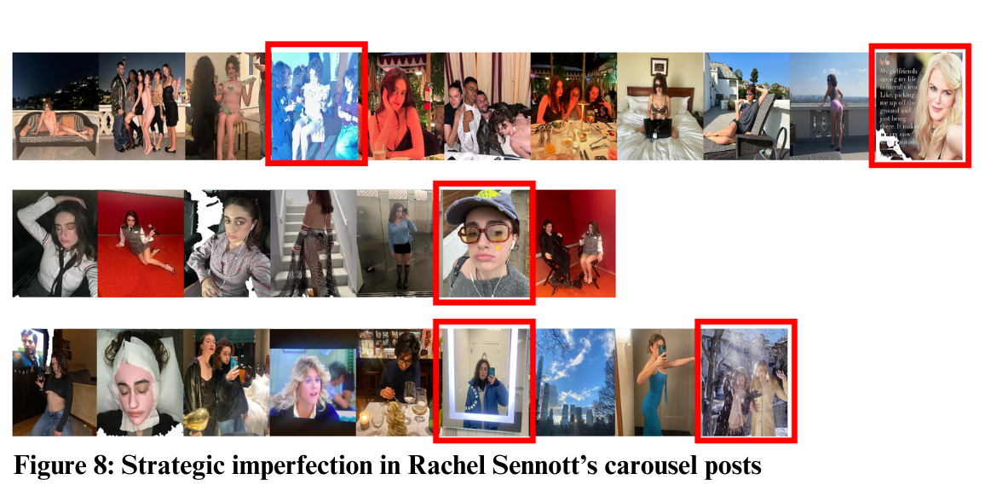

These images show two versions of what I call **calibrated authenticity** — one from TikTok, one from Instagram. The top figure here shows **strategic imperfection** in Instagram photo carousels. Here, actor Rachel Sennott mixes glamour shots with blurry candids, group chaos, and unflattering angles — the kind of images that signal relatability and self-awareness without abandoning aesthetic control. These posts are designed to feel natural, but not too natural.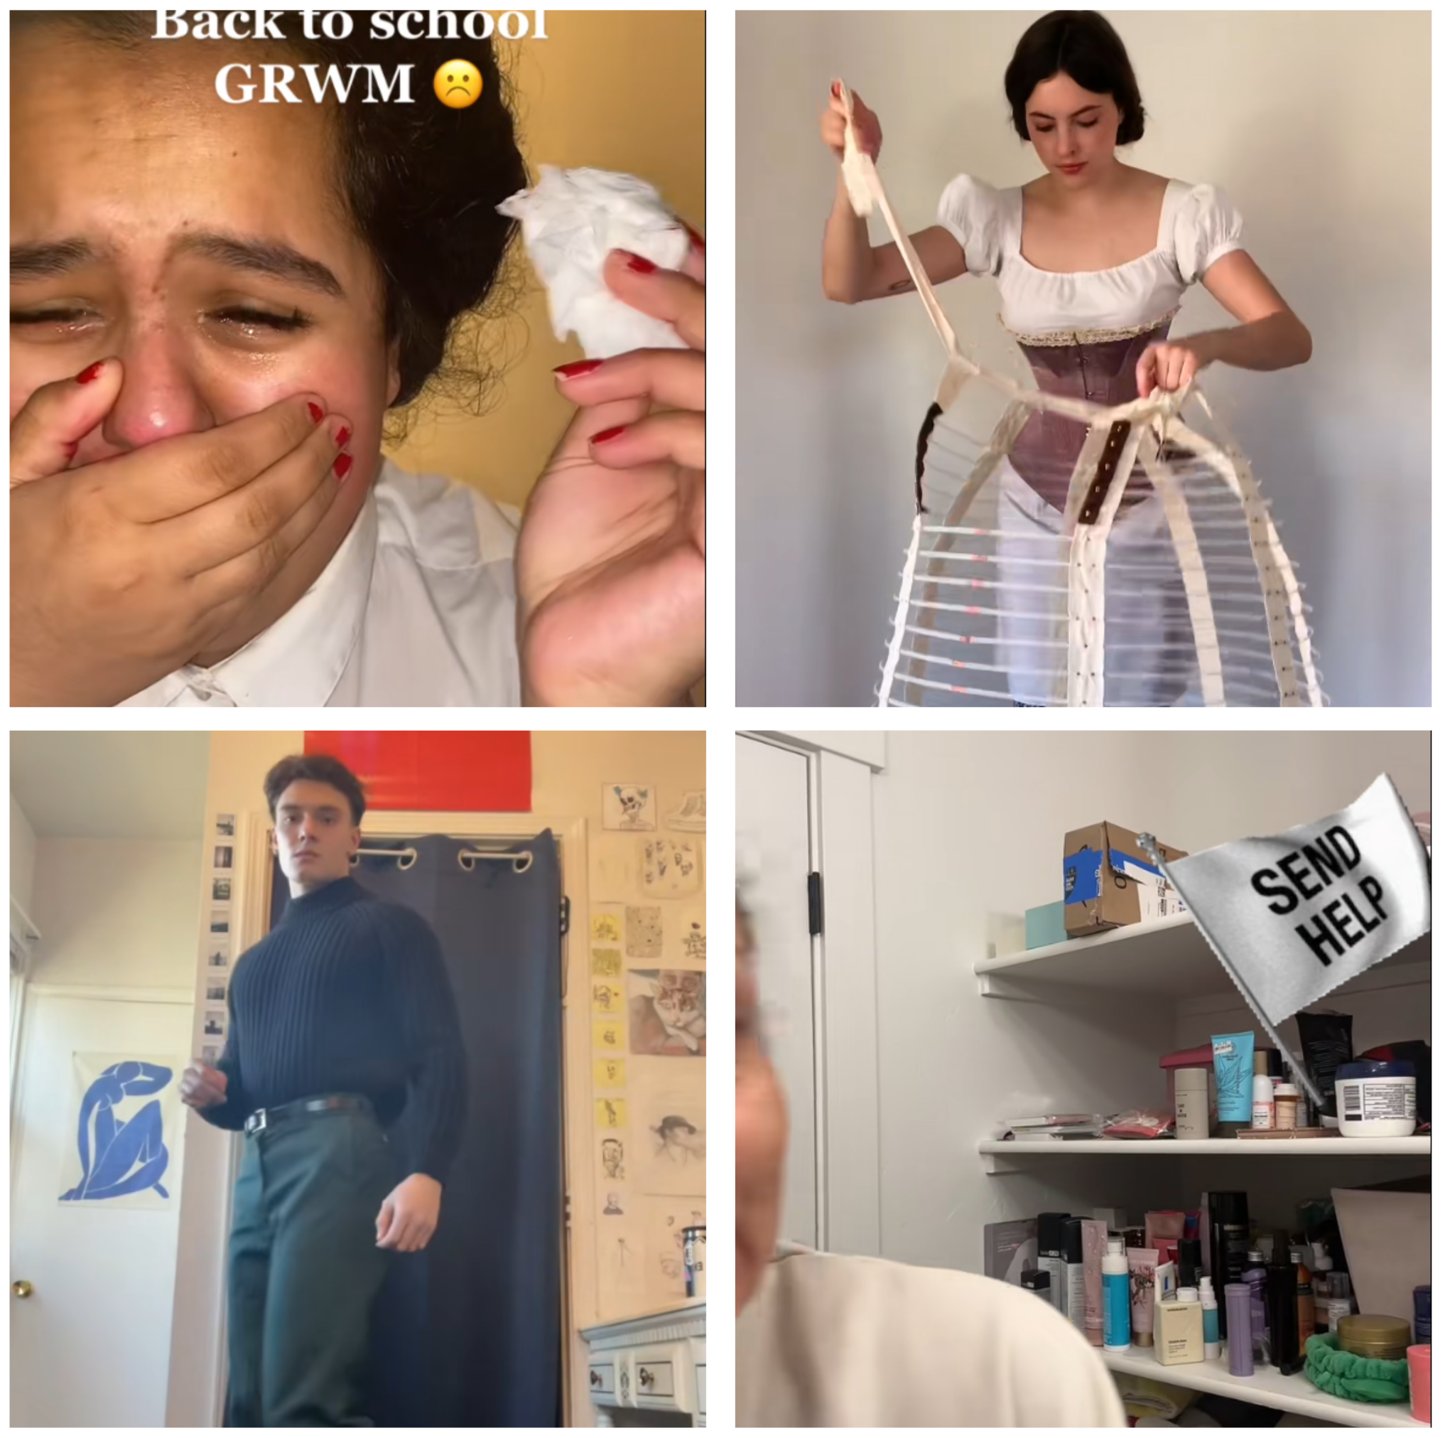

The second image here includes screenshots from GRWM videos and lo-fi skits that embrace awkwardness and emotional honesty, but do so in ways that feel deliberate and stylized. They “perform” messiness in a format that feels native to the app.

The top rows, by contrast, In both cases, users manage the tension between authenticity and performance by carefully crafting a kind of visible effortlessness — one that resonates with each platform’s rhythm, tone, and expectations.

### **2. Individuality vs. Collectivity → Networked Individuality**

Users often borrow from collective formats — like Starter Pack memes or TikTok skits — to express something personal. These formats create a shared language, but leave room for specific, even hyper-individual twists.

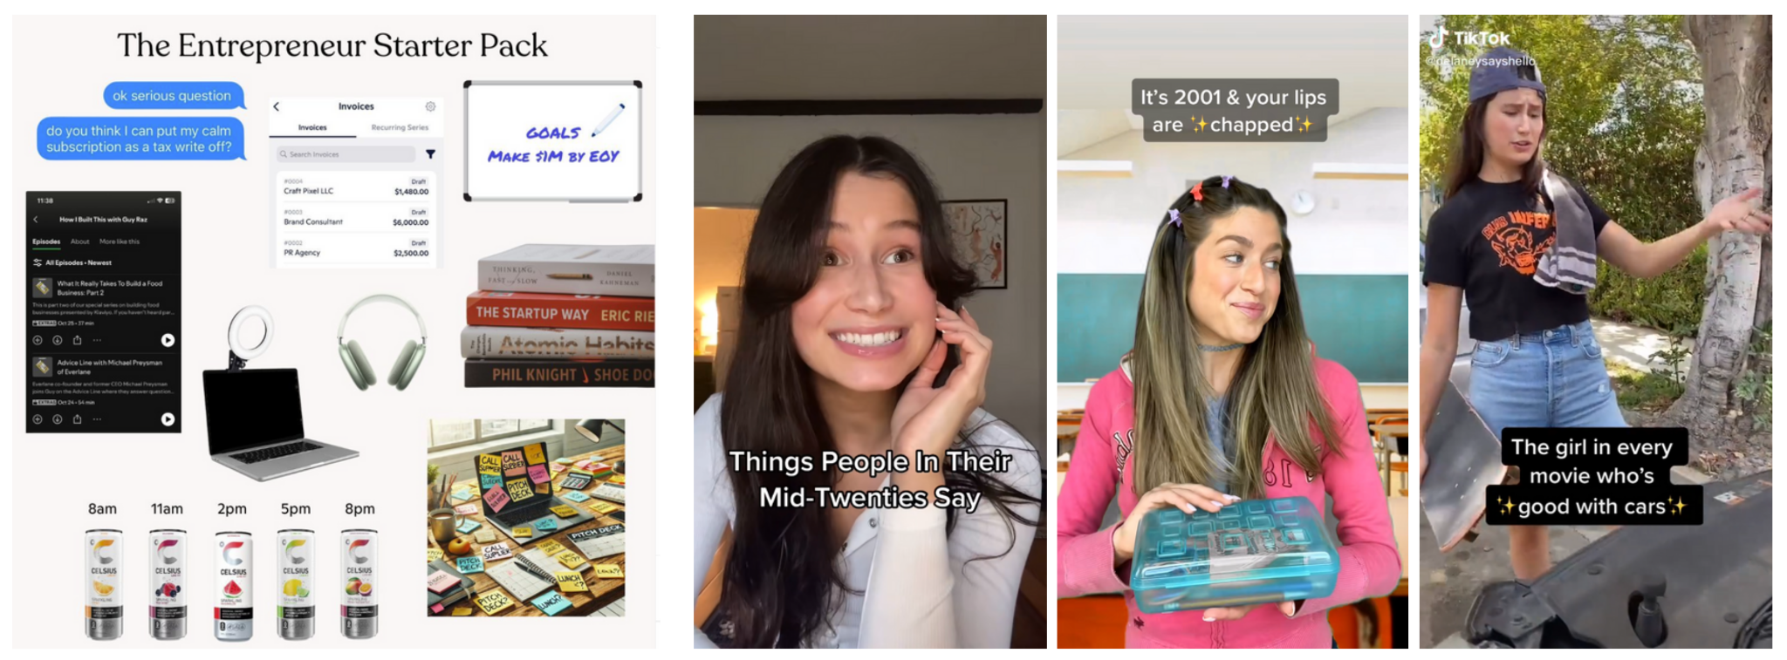

In each of these examples, users take a recognizable format — a Starter Pack layout, a TikTok skit setup — and make it their own. The “Entrepreneur Starter Pack” plays on common design elements, but updates the references for a niche subculture. The “Things People in Their Mid-Twenties Say” video uses a well-known structure (captioned impressions) to poke fun at a highly specific life stage. And the TikToks on the right tap into nostalgic or hyperlocal identities: 2000s lip balm girls, car-savvy girls, the girl in every movie who’s good with cars.

These formats act like templates: they invite participation while encouraging users to personalize. That personalization can be aesthetic, referential, or even just tonal — a certain kind of delivery or editing choice that signals a distinct voice within the collective.

This is what I call **networked individuality**: a way of expressing selfhood that doesn’t reject shared culture, but instead builds on it. On platforms like TikTok and Instagram, standing out often means participating in — not avoiding — recognizable trends. The creative work is in how you bend the format to speak for you.

### **3. Innovation vs. Convention → Constrained Creativity**

Originality matters online — but so does fitting in. Users often walk a tightrope between standing out and following the rules of the platform. To do that, they innovate **within** conventions: remixing familiar trends, but adding a clever twist.

One especially interesting example is called **“subtle foreshadowing.”** On **TikTok**, users take a video that builds to a funny or dramatic moment — like someone falling off a slide — and splice the ending back into the beginning. This disrupts the usual build-up/punchline structure, and creates a layered joke. Viewers aren’t just surprised — they’re invited to notice the disruption and share in the setup.

On **Instagram**, where users can’t edit video in quite the same way, creators adapt the idea differently. Some use **carousel posts** (multi-image slideshows) to set up a kind of reveal — for example, starting with polished or normal-looking photos and ending with something chaotic, surprising, or messy. The viewer has to swipe through the sequence, mentally stitching together the story. Other times, users play with the **caption** — labeling a seemingly normal photo as “subtle foreshadowing,” so that followers start looking for a hidden meaning or twist.

What connects both versions is the underlying impulse: to take a familiar format and tweak it just enough to feel fresh. The joke isn’t just the content — it’s in the structure, and in the way creators use (or subvert) the tools of the platform to make viewers feel in on the trick.

**Memetic Negotiation** isn’t just creative — it’s strategic. People are constantly responding to what platforms are more likely to show to others — and what kinds of content they quietly push to the top, based on how the algorithm works. And those conditions differ: TikTok’s design rewards rapid-fire iteration and low-stakes experimentation. Instagram still leans toward polish, aesthetic coherence, and social ties.

These aren’t just vibes — they’re structural differences. And they shape how users resolve the tensions they feel while posting. Memes aren’t just jokes or trends. They’re tools for managing identity, connection, and visibility in a highly mediated world.

## 

## **Chapter 4: What Happens When Memes Move Between Platforms**

Maybe you’ve seen a TikTok reposted to Instagram, watermark still visible. Or a meme you recognize — but it feels different. The caption’s changed. It became a carousel post instead of a video. Something about it shifted.

That’s **memetic translation** — when a meme changes form to survive on a new platform.

When memes move from one platform to another, people adapt them — not just to avoid getting buried by the algorithm, but because each platform demands something different. A TikTok doesn’t automatically work as an Instagram Reel. The aesthetics might clash. The timing might feel off. The humor might not land. And users know this.

Sometimes it starts with a simple concern: **visibility**. Many people believe (rightly or wrongly) that platforms like Instagram downrank videos with a TikTok watermark. So users crop it out, re-upload it, or recreate the content from scratch.

But those changes aren’t just technical — they’re cultural. Platforms reward different kinds of content — not just in what goes viral, but in what feels right, looks native, or fits the feed. They have different rhythms, tones, values, and interaction styles. So users adjust their memes accordingly: tweaking how they look, how they feel, and what they mean.

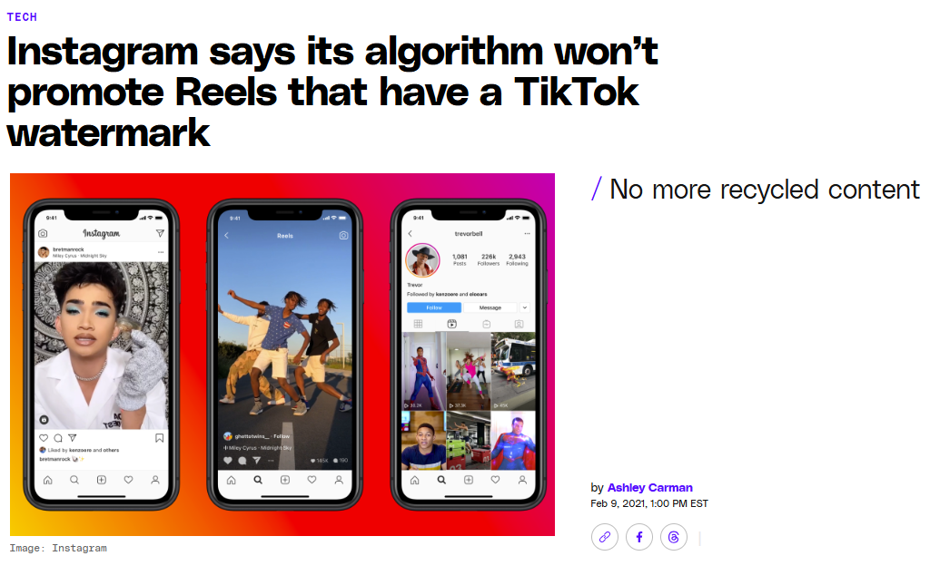

To make sense of how this works, I introduce a simple framework:

**The Three-Step Model of Memetic Translation.**

This isn’t a rigid checklist — and no single person goes through all the steps. It’s more like a group improv scene than a solo performance: iterative, collective, and always in motion.

### **1. Structural Adjustment**

This is the first step, where the meme’s format gets changed to match a new platform.

A long TikTok might be trimmed to fit Instagram’s time limits. A video built around a remixable sound might be reworked as a captioned clip, since Instagram doesn’t support audio the same way. Or a layered video might be turned into a static image carousel.

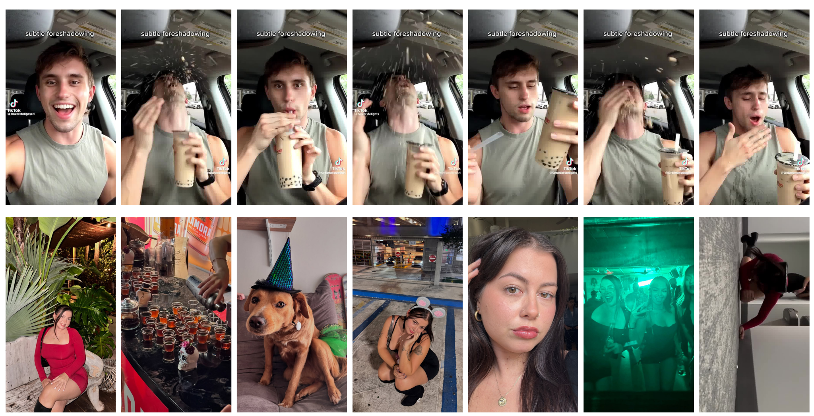

On TikTok (top row), the "subtle foreshadowing" trend splices the end of the video into the beginning — the punchline appears early, then the rest builds toward it. This structural play depends on TikTok's looping format and easy editing tools.

On Instagram (bottom row), users adjust the trend by moving it into a **carousel post**. Instead of one looping video, the payoff comes in the final image after a series of unrelated or misleading ones. It’s still foreshadowing — but it’s reshaped to work with Instagram’s swipe-through logic.

This is **structural adjustment**: changing the format of a meme to match the features and flow of a different platform.

### **2. Semiotic Recalibration**

That’s a fancy way of saying: the *tone and meaning shift* to fit a new context.

On TikTok, the Corecore trend is known for fast cuts, glitch aesthetics, and ironic audio overlays that blend humor with emotional depth. But when this style moves to Instagram, the visuals and pacing change dramatically.

Here, the content becomes more still and reflective: paired images, moody captions, poetic overlays. The irony fades; sincerity takes center stage. This is **semiotic recalibration** — the same emotional concept is being explored, but it’s communicated in a very different way. The message hasn’t disappeared — it’s been translated.

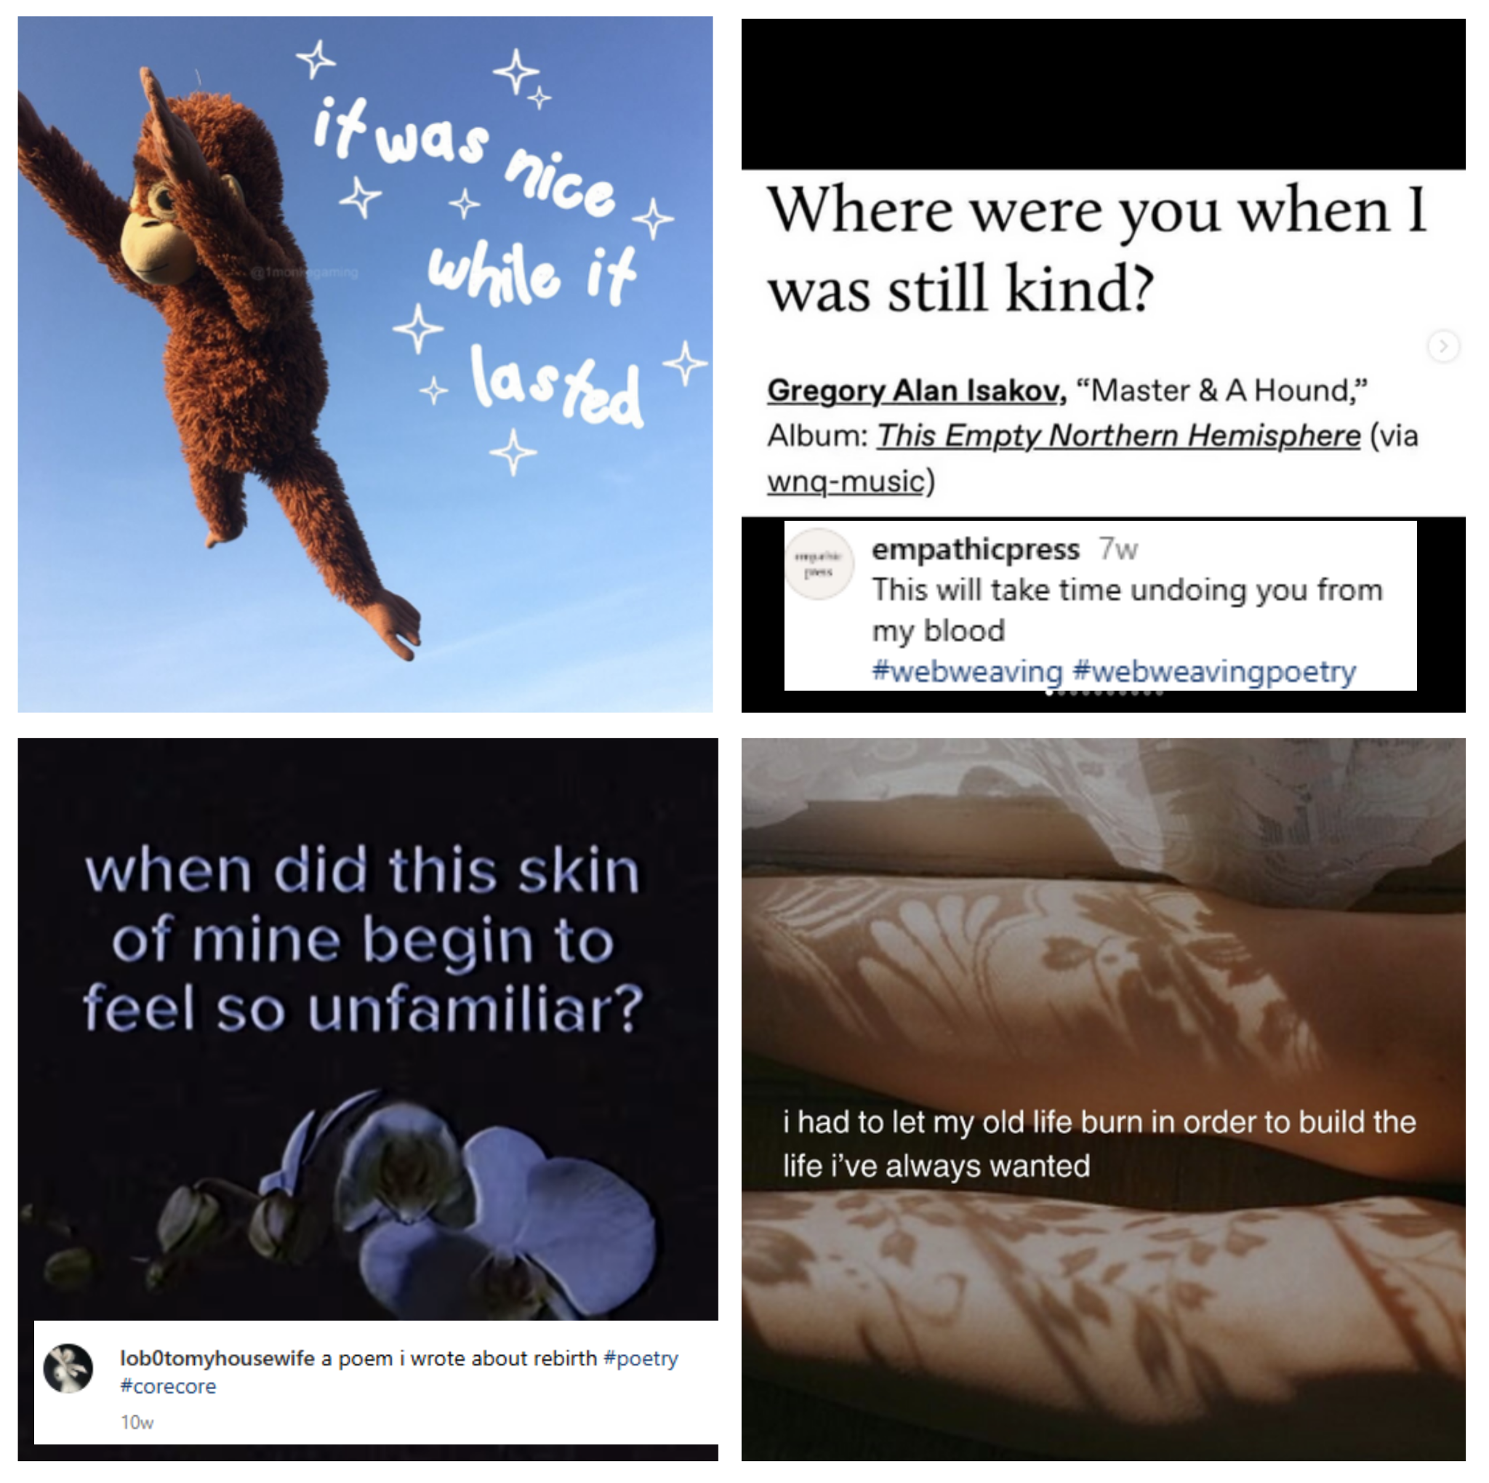

### **3. Cultural Integration**

Not every meme survives the move between platforms. This figure shows what happens when one kind — serialized storytelling — tries to make the jump. On TikTok, creators like @veronikaiscool built loyal audiences through narrative skits that unfold in parts, aided by the algorithm’s support for ongoing series. But on Instagram, the same content has to be split across posts, hidden within carousels, or paired with unrelated videos.

The structure becomes fragmented. Story arcs get broken up. And visibility depends more on social ties than algorithmic surfacing. This is the challenge of **cultural integration**: some memes find ways to thrive in new settings — others become harder to follow, or lose momentum entirely.

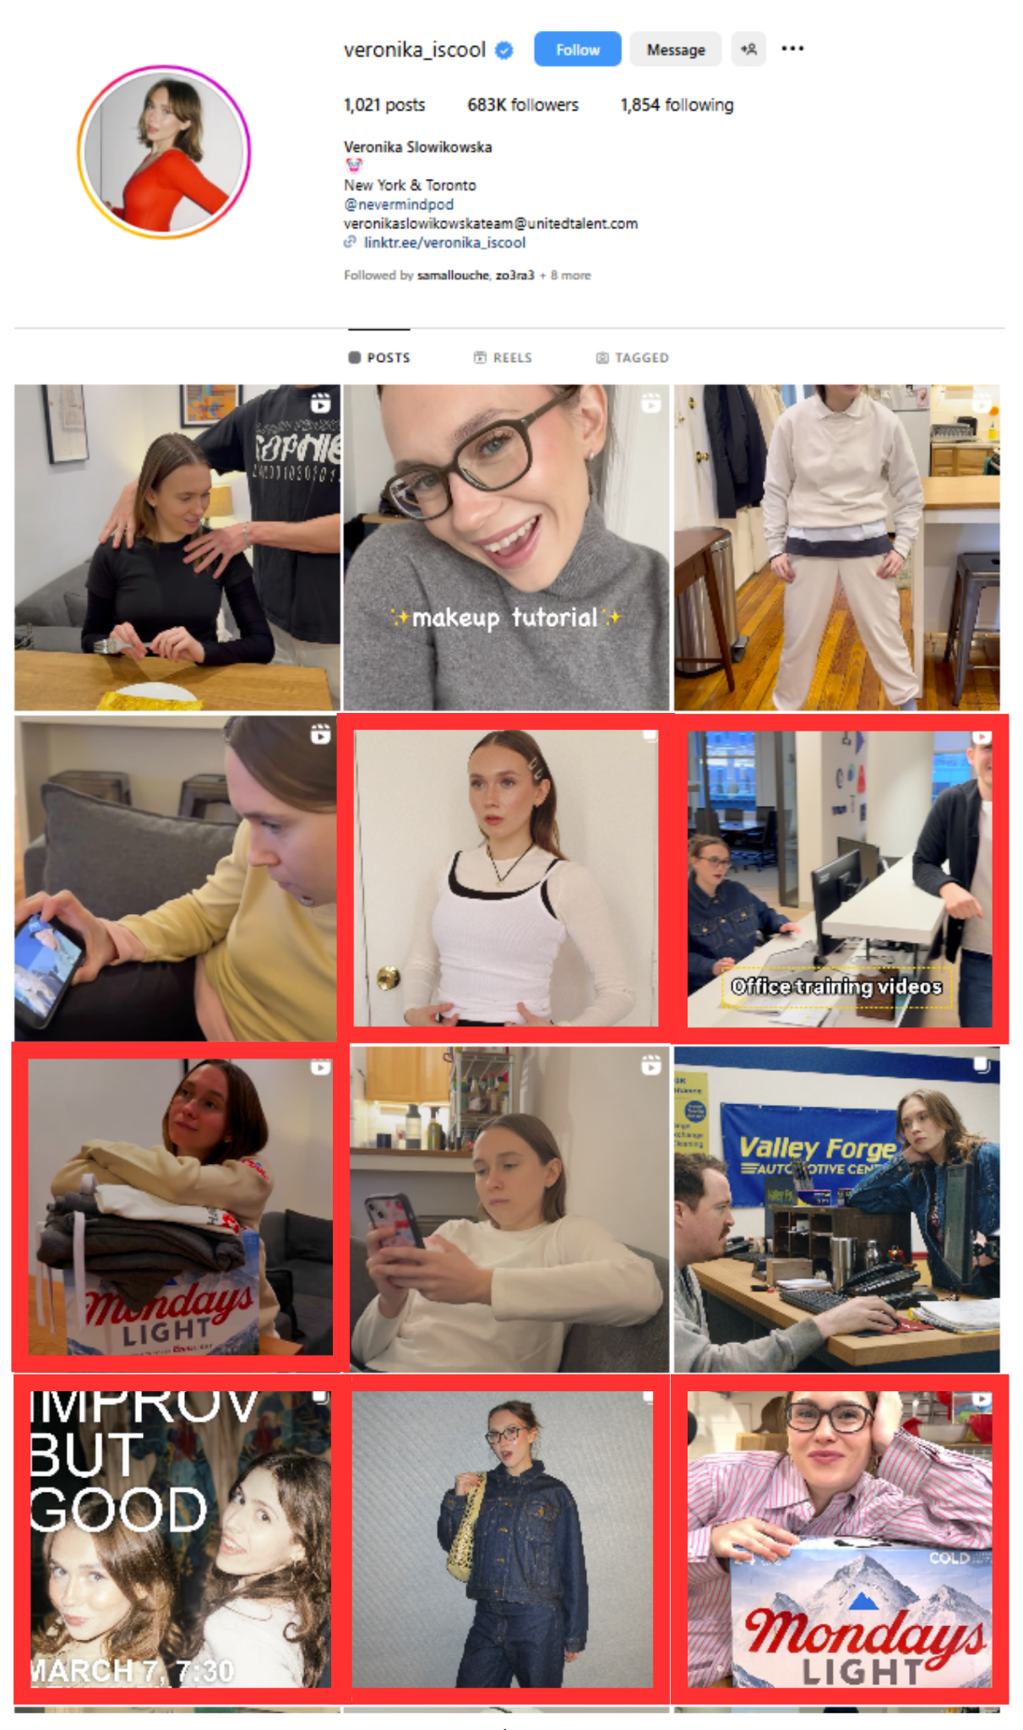

The key idea here? **No one controls this.**

Memetic translation doesn’t happen by design — it happens *in the wild*, through thousands of small, creative decisions by users. It’s a distributed, cultural process. It’s people trying, tweaking, copying, failing, adjusting — until something sticks.

And all of it points back to the core argument of this project:

Platforms aren’t just containers where content gets uploaded. They shape what’s possible, what spreads, and how creativity works. When a meme crosses platforms, it doesn’t just move — **it transforms**. And that transformation reveals something essential about the platforms themselves — not just as apps, but as cultural environments.

**Chapter 5: Platforms, Culture, and the Hidden Rules of Creativity**

Memes might look like jokes, distractions, or cultural noise — but they’re also **diagnostic tools**. By paying close attention to how memes are made, shared, and transformed, we can learn something deeper: how platforms shape creativity, visibility, and cultural meaning in everyday life.

This project has followed memes across three layers: how platforms define creative values, how users navigate tensions through practice, and how content changes when it moves between platforms. Along the way, one thing becomes clear: **online creativity isn’t just expression — it’s negotiation**.

Platforms set the terms of participation. They define what “authenticity” looks like, what kinds of content are easy to make, and what gets seen. Their algorithms determine who gets attention. Their design features subtly push some behaviors while making others more difficult or invisible. In short: **platforms structure the conditions of cultural production.**

Users, in turn, respond. Not passively — but strategically, creatively, and often with humor or irony. They remix trends to express themselves. They walk the line between originality and convention. They calibrate posts to seem authentic *and* appealing. They adapt, subvert, and play — but always within the bounds of what the platform makes possible.

This is what I call **structured participation**: the idea that participation online is never freeform. It’s always shaped by the systems that host it. And memes — in their remixable, iterative, and highly responsive forms — are where that structure becomes visible.

When we zoom out, we can see how these dynamics function not just within a single app, but across platforms. As memes move from TikTok to Instagram or vice versa, they often change — sometimes in form, sometimes in meaning, sometimes in whether they survive at all. These transformations aren’t accidental. They reveal each platform’s logic: how it organizes attention, constructs value, and defines cultural participation.

Memes, in other words, don’t just reflect culture — they help **build** it. They’re where users work out platform norms, where new aesthetics emerge, and where tensions between users and infrastructure are negotiated in public.

This isn’t just about TikTok or Instagram. It’s about the cultural systems that increasingly shape our online lives. Platforms don’t just show us content. They shape what kind of content exists in the first place — and who gets to be visible, creative, or influential.

So what does this all mean?

It means memes are more than entertainment — they’re **maps of power and participation**. By watching how people create and adapt them, we can see how digital culture is being shaped: not just by users, but by platforms themselves.

It means creativity online isn’t just about talent, voice, or effort — it’s about learning to move through systems that reward some expressions and filter out others. Platforms don’t just show us what’s trending — they help determine what *can* trend.

And it means we can’t understand digital culture — or who gets seen, heard, or understood — without also understanding how platforms operate.

This work also speaks directly to the ways social media is talked about in public life. When people worry that TikTok is addictive, or that Instagram makes us feel fake, or that algorithms are making everyone miserable, those are real concerns — but they often miss the mechanics.

They treat platforms as if they’re just apps with bad vibes or too much screen time. What this project shows is something more specific: **platforms shape culture by design.** The way we talk, joke, express ourselves, even imagine authenticity — it’s all filtered through these structured environments.

Understanding that helps us ask better questions. Not just “Is TikTok bad for kids?” but “What kinds of creativity does TikTok enable, and what kinds does it suppress?” Not “Why is Instagram so curated?” but “How do Instagram’s design and values encourage curated performance?” These are finer-grained, more useful questions — for users, for researchers, for designers, and even for policymakers.

So yes, there are **big-picture stakes** here — about power, visibility, and cultural futures. But there are also **tactical insights**: into how people adapt to systems, how creativity gets coded into platforms, and how cultural participation is always a little more structured than it seems.

Memes may be fleeting, but the structures behind them are durable. If we take memes seriously, we gain a new lens on the cultural systems that shape our digital lives — and a better starting point for imagining what comes next.

